Recreating “Validating the paraphrase methodology” experiment 1 by Gregory Scontras and Noah D. Goodman

## Background

Semantics and pragmatics have always been and highly active field of research in linguistics. Predicates allow us to assign properties to objects – but especially in plural sentence environments multiple assignments are possible. This design gives subjects an utterance and a choice between two sets of objects. The subject’s task is now to decide to which set of objects an imaginary worker in a warehouse referred to. An example stimulus is presented in *figure 1* below.

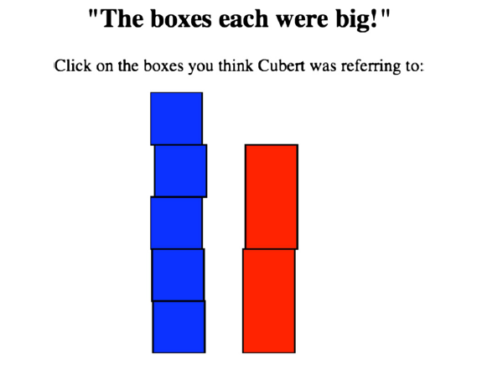

Figure : Example stimulus for the plural prediction experiment

When exposed to an utterance like in *“The boxes are heavy”*, one can either assign heavy a distributive (i.e. *the boxes each are heavy*) or a collective (i.e. *the boxes together are heavy*) meaning. However, some predicates, like *“big”* are not assigned the collective role in most cases. This “stubborn distributivity” (Schwarzschild (2011)) is well documented since 1960 (Quine, 1960) but there is still no consensus as to why humans as young as 3 years old use certain predicates only in certain ways. One reason could be that the *contextual predictability* of a predicate, when applied to a collection of items, affect assigned meaning. In other words, a less stable predicate (which depends more on context) will be less likely interpreted in a collective fashion.

This experiment is investigating whether the words *“each”* and *“together”* can be used to unambiguously access distributive and collective semantic interpretation.

## Hypotheses

1. Without disambiguation words (sentence frame = bare), *stubborn distributive* predication, i.e. the predicate is either “big” or “tall”, behave distributive.
2. The collective disambiguation (sentence frame = “together”) is assigned a collective meaning in most cases.
3. The distributive disambiguation (sentence frame = “each”) is assigned a distributive meaning in most cases.

## Design

### Materials:

### We will use only one picture. We won’t have a practice part. The picture has two different stacks of boxes. One stack contains two big boxes and the other one five smaller ones. Accordingly, the … sentences consist of: “The boxes V1 were V2”.

V1 = “each” / “together” / bare

V2 = “big” / “heavy” / “tall”

### Procedure:

1. Introduction
2. Instruction
3. Test phase
4. Post-experiment questionnaire + Thank you

The participants are welcomed and introduced to Pip, a factory worker who **inspects** or **moves** boxes. The participant knows in which condition he is by looking at a picture with an explaining text. Pip either has a moving cart or he does not. Pip then talks to his friend Jim after having inspected or moved the boxes. The participant helps Jim to decide which stack Pip was referring to in the test phase. Either the one which implies a collective interpretation (five small boxes) or a distributive interpretation (two large boxes which are together smaller than the five small boxes). After clicking on the chosen stack of boxes the next sentence immediately appears.

There are three predicates Pip can use: “*big” , “heavy”* and *“tall”* in three sentence frames: *“bare”, “each”* and *“together”*. The participants have 9 trials, consisting of all combinations in a random order.

In the end, participants can fill out an optional questionnaire and are being thanked for participating in the experiment.